REGISTRATION FORM

School or Organization:
Contact: Email address:
Location:

Phone: Ext. Fax:
Preferred method of payment:
Preferred method of contact:

Proposed Dates: 1st choice 2nd choice
Time  (One hour intervals) | Grade | Number of Students | Teacher

Additional Comments or Special Requests:
Please allow at least 2 weeks for cancellations. Contact us if you have any questions or changes in the number of students that will be in attendance.

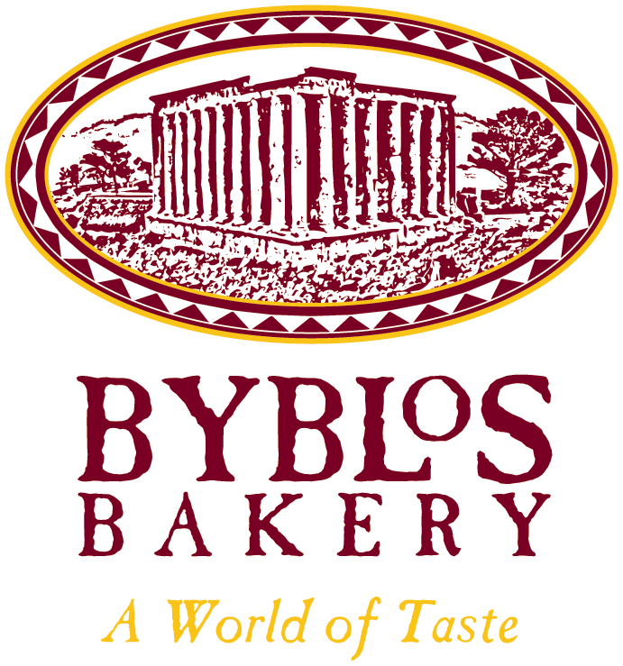
Jamie Gervais
Byblos Bakery
2479 – 23rd St. NE
Calgary, AB T2E 8J8
Head Office: 403-250-3711
Web: http://byblosbakery.com

B.Sc. in Nutrition and Food Science
Nutrition Educator
Email: pitasake@byblosbakery.com
Web: http://foodimpact.ca
Cell: 587-435-7026

